

Every Conversation Matters

Scope of Work
Submitted To:

< Client Logo/ Name >

Document Control

Revision History

Version Number | Last Update Date | Change Description | Author/Editor Name | Approver Name

Approvers
Approver Name | Title | Date Approved

Reviewers

Reviewer Name | Title | Date Reviewed

1. Business Objectives Discovered

Key Objectives and Indicators
Description | Client requirement
Business Objective
Business Problem
Use Case Narrative | (Mention the use-case in brief for e.g. deploying a bot on WhatsApp for students with Live Chat with Video Calling integration)
Expected Volumes
Target Audience | - Active Users  - Dormant Users  - Churned Users
KPI’s / Success Criteria for Project

2. Technical Requirements

Overall Requirement
Description | Client requirement
Number of journeys
Channels | - WA  - WA Voice | - SMS  - Others | - Instagram  - PSTN Voice
Bot Language
No. of APIs/Backend Services to be Integrated into the bot for fetching/pushing the data in/out of the bot | (Please mention the total number of backend services that you want to integrate)
Name of the backend systems in scope
Development Timelines ( In Mandays )
Note : Development and Delivery timelines will vary

AI Specifications
Description | Client Readiness/Requirements
Bot type | Agentic
Channel | Chat
Use-Case Category | FAQ
Bot Complexity | Simple
LLM Model | ( STT and TTS Models if Voice AI )
Type of Training data | - CSV  - Website  - Text  - Others (Please specify ex: SFTP, Gdrive)
AI Languages | Refer here
Estimated No. Questions/intents/FAQs to be uploaded in the bot
Testing Data :  Questions & Answers shared by customer | Sample File

- Voice Specifications
Description | Client requirement
Dialer | Knowlarity
Voice Cloning ( Add Sample If Yes ) | No
Call Type | Inbound
Voice Samples for Cloning
Channels | - PSTN  - WA Voice
SIP EndPoint (For WA Voice calls termination)
WABA Number to Enable WA Voice
Websocket URL (If Voice calls need to be terminated to third party AI)

- Deployment/Hosting
Description | Client requirement | Questions | Presales Findings
Deployment/Hosting |  | What mode of deployment is required?

Capacity and Compliance
Description | Client requirement | Questions | Presales Findings
TPS | Standard 80 | What is your average campaign size? | - What is your average campaign size?  - How big is your customer base?  - How many campaigns per day are expected to go out?
TPS | Standard 80 | How big is your customer base?
TPS | Standard 80 | How many campaigns per day are expected to go out? | Not exceeding 25M messages/day
Data Retention | 2 years - Standard | How many years of data retention is required? | - How many years of data retention is required?  - What user data parameters are required?
Data Retention | 2 years - Standard | What user data parameters are required?
Profile Storage Requirements | Upto 2 Million | How big is the customer base? | - How big is your customer base?
Security and Privacy Package | No | Encryption Required? | https://docs.google.com/document/d/1Ktg5xzc7cGbC5yCm2TDnOxvsDqSYZUmae7MNxwmFMSk/edit?usp=sharing
Security and Privacy Package | No | Which encryption standards/methods are required?
Security and Privacy Package | No | BYOK?
Security and Privacy Package | No | Audits?
Security and Privacy Package | No | Message searcher?
Security and Privacy Package | No | Purging certificate?
Security and Privacy Package | No | Data dump?
Security and Privacy Package | No | GDPR compliance support?

Channels : Delete if no CPaaS in the deal.
Description | Client requirement | Questions | Presales Findings
Instagram |  | Do they also use IG for running ads?
Instagram |  | Do they use a social listening tool to manage comments and replies
3rd Party CPaaS Integration - No standard connectors | Yes | Which system/sources will send traffic to Gupshup? | - Which system/sources will send traffic to Gupshup?
Failover | Yes | Which channels need to be supported? | - Which channels need to be supported?
Custom reports | Yes | How many and what parameters are required for custom reports? | - How many and what parameters are required for custom reports?  - Frequency of reprts sync  - SFTP required?
Custom reports | Yes | Frequency of reports sync
Custom reports | Yes | SFTP required?
Billing Formats | No

Additional Scope Elements
Description | Client requirement | Questions | Presales Findings
Dedicated BA and Project Manager | Yes | How many are required? | How many are required?
Dedicated Developer | No | How many are required? | How many are required?
Solutions Mode Bot | No | - Only for BFSI clients | - Only for BFSI clients
3rd party events integration with personalize | Yes | -Which Systems | - Manday rate
3rd party Agent Handover | No | - Which systems are required?  - Understanding the flow - Brand wants to use GS JB & Campaigns & 3 P AA or just GS campaigns & 3P AA for bot and AA?  - API documents for Sending chat history to 3P AA, Sending of Real Time events to 3P AA, Getting real time events from 3P AA, & How to transfer the handover from bot to 3P AA & How to take back the handover from 3P AA to GS Bot  - How many chats per day/week/month?  - Data retention on Gupshup side? Time period.  - Assignment logic to be maintained at Gupshup end or no?  - Number of WABAs to be onboarded & are they required to be onboarded on single dashboard or multiple dashboard? | - Which systems are required?  - Understanding the flow - Brand wants to use GS JB & Campaigns & 3 P AA or just GS campaigns & 3P AA for bot and AA?  - API documents for Sending chat history to 3P AA, Sending of Real Time events to 3P AA, Getting real time events from 3P AA, & How to transfer the handover from bot to 3P AA & How to take back the handover from 3P AA to GS Bot  - How many chats per day/week/month?  - Data retention on Gupshp side? Time period.  - Assignment logic to be maintained at Gupshup end or no?  - Number of WABAs to be onboarded & are they required to be onboarded on single dashboard or multiple dashboard?  -

Flow Diagram & Gantt Chart
(Optional for Presales, Important/Requisite for Delivery)
Sample Script Voice Ai
Sample Gantt Chart

3. Packaging and Inclusions

One time Dev Costs :

Monthly Recurring Costs :

<<insert from calculator output>>

https://pricing-calc-production.up.railway.app/

4. Delivery
Stakeholders from Gupshup(if known at the time of this document)
Roles | Responsibilities | Credentials
Sales | Sales will be responsible for daily communication and ensuring business operations continue as usual.
Presales | Pre Sales will be responsible for ensuring the kickoff between Gupshup's development team and the client team, as well as documenting the Statement of Work (SOW) with all requirements.
Growth  Manager | Will own the SOW and work with customer to define the phases of deployment mapped to KPI’s
BA | The BA/project manager will be responsible for scheduling, planning, and coordinating the implementation.
Development/ Quality Assurance | The development team will work closely with BA and take requirements for developing the chatbot, Quality assurance will ensure that the bot meets the desired standards, is functioning as intended, and is free from bugs and operational issues.
Onboarding & Training | The onboarding and training team will ensure that the client is well-versed in the functionalities and features of the platform, and will also be responsible for facilitating a frictionless onboarding process.
Support | The support team shall always be available for query resolution under the contract terms and will serve as the first point of contact for any issues in maintaining business continuity.
Security & Compliance | Optional
Customer Success | Customer Success will be responsible for providing regular status updates and growth insights, as well as managing day-to-day operations, handling escalations, scheduling cadences, and other related tasks.
Stakeholders from <Client Name> (Optional if known)
Roles | Responsibilities | ABC client
SPOC
Finance
Marketing
Operations

5. Project Management
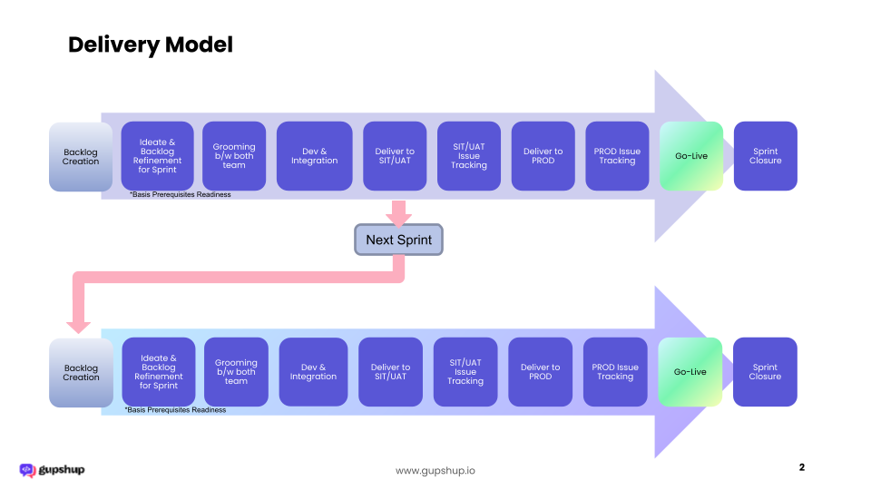

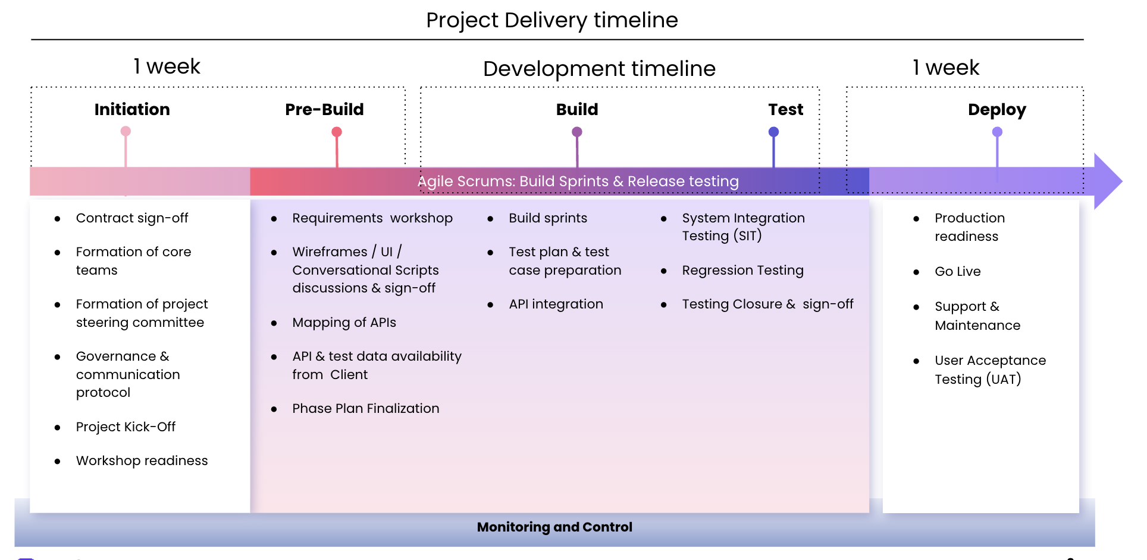

6. Project Governance
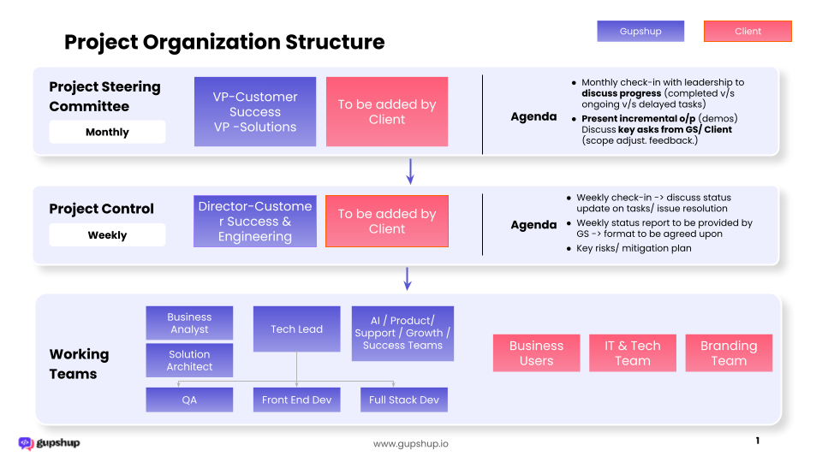

7. Confidentiality and Security
Data Security
- The solution will be hosted in Gupshup’s AWS, India (default)
- The production environment will be hosted in production-grade servers isolated from the development and staging environments using containerization and logical separation.
- All production data transpired in the chat window will be stored in the cloud data center with end to end encryption enabled using AES 256 algorithms.
- PII data will be masked and will not be visible to any user.
- The interactions in transit will be HTTP(s) enabled.
- Developers will have access to Dev & Staging environment only
- The user interface is password protected at all levels.
- Clients have the option to transfer all the data to their data center. Custom integration efforts will be required for this function.
- The data transfer, archiving & purging frequency & mechanism to be defined during design stages and executed during the project.
